***Summary****: Any themes proposals to bring RC and/or Springville ES down south across Highway 26 make no sense from traffic perspective.*

1. **Sending school traffic across zoning boundary Hwy 26 break the traffic patterns anticipated in regional planning and thus adds to unexpected consequences.**

In transportation planning, the region is divided into smaller areas called traffic analysis zones (TAZ). Usually the natural borders like rivers, highways, railways, reservoirs are the dividing lines that delineate the TAZs. Below is the TAZ map for the entire Portland metro area ([https: //www.oregonmetro.gov/regional-forecast-allocation-data-sets](https://www.oregonmetro.gov/regional-forecast-allocation-data-sets)) 

Figure Portland Metro area traffic analysis zone overview

Figure Portland Metro area TAZ concerning BSD rezoning efforts

Highway 26 is the divider border for these residence area that feed into the elementary schools to either the south or the north of this natural border (TAZ 1147, TAZ 1191 etc). As a general rule of thumb, the school traffic should be kept to roads that serve these communities. These zoning and resulting roadway capacity designs and maintenance projections are the basic guide for resource allocation by cities, counties and department of transportation (DOTs) at local and state levels.

As school traffic is and should be local traffic, it is generally directed onto local roads rather than major thoroughfares. Breaking such design patterns will sometime result in undesired consequences from planning perspective, typically reflected in unbalanced road capacity utilizations and uneven traffic congestion concentrations.

Unfortunately, in all three themes so far, we see the main idea is to send Springville ES and RC ES onto the major thoroughfare 185th Ave. As school traffic is not just school buses, but also parents visits/drop-offs and school activities, *dragging* a large student body from north of Hwy 26 over to the south will inevitably introduce traffic deviate the designed traffic patterns. This is a much less desired change from the transportation planning viewpoint.

1. **Artificially introducing school traffic onto already busy NW 185th can lead to unnecessary worsened traffic congestion and impact the local community or even the region.**

As the Beaverton-Hillsboro part of the metro area keeps booming, it has seen rapid growth along 185th Ave and especially to the north of TV Hwy. Today, this major thoroughfare is getting busier with a mixed traffic of long-distance traffic, shopping and deliveries at Tanasbourne shopping center and other adjacent commercial and business parks, and local community economic and social activities as well. As such, the traffic is busy most of a typical weekday, as reflected by a Google Maps traffic for a Monday daytime: <https://www.youtube.com/watch?v=7sxu3iZCkvs>

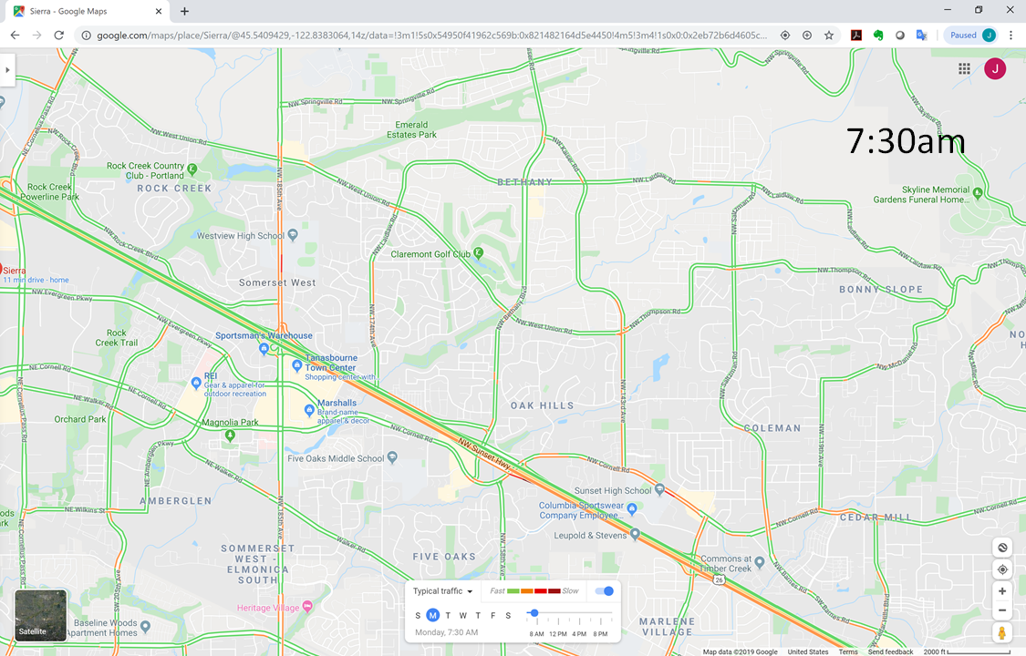

Figure Morning peak time in the Tanasbourne area, witnessing strong southbound traffic jam on 185th to the north of Hwy 26

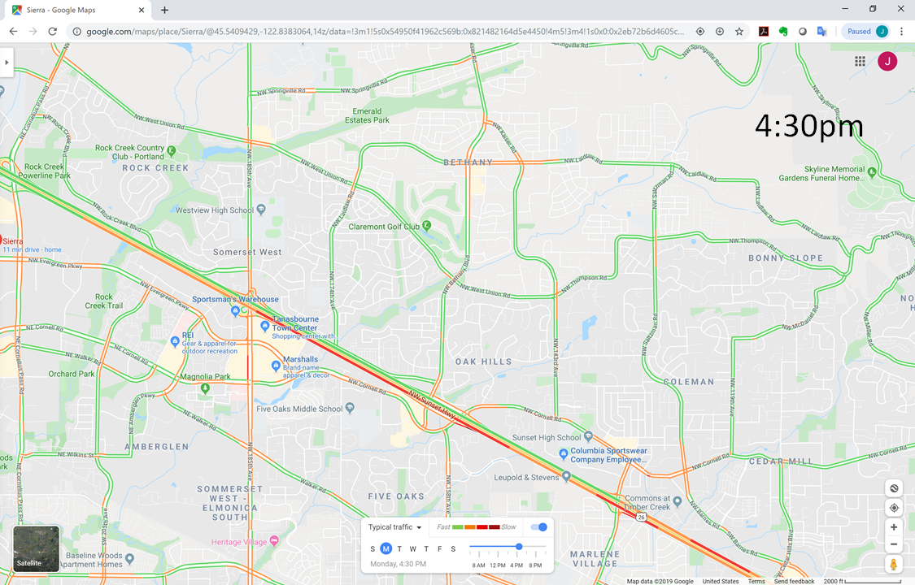

Figure 4 Morning peak time in the Tanasbourne area, witnessing strong traffic jam on 185th in both directions to the south of Hwy 26

From the short video, it is clear that the tidal traffic is divided by Hwy 26: in the morning, the 185th southbound is congested till 10am to the north of Hwy 26, while in the whole afternoon both directions of 185th is congested to the south of Hwy 26. In these cases, we normally can say the stretch is ‘overcapacity’.

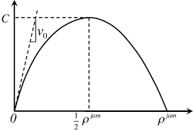

The classic traffic flow model by Greenshields in 1935; the traffic congestion will worsen sharply once overcapacity and reach breakdown quickly

If both Springville and RC ES school traffic is added to this congestion, we can logically imagine the congestion will be much worsened, and may reach breakdown fairly quickly (it may occur by the economic growth by itself, but adding school traffic artificially will certainly not help in the situation.

Tied to the first planning Investment to more lanes is the usual solution but will call for huge amount for e.g. widening an overpass at 185th across Hwy 26.

At the same time, we have to consider the emergency vehicle impact. Below is a map that shows the fire stations in this area:

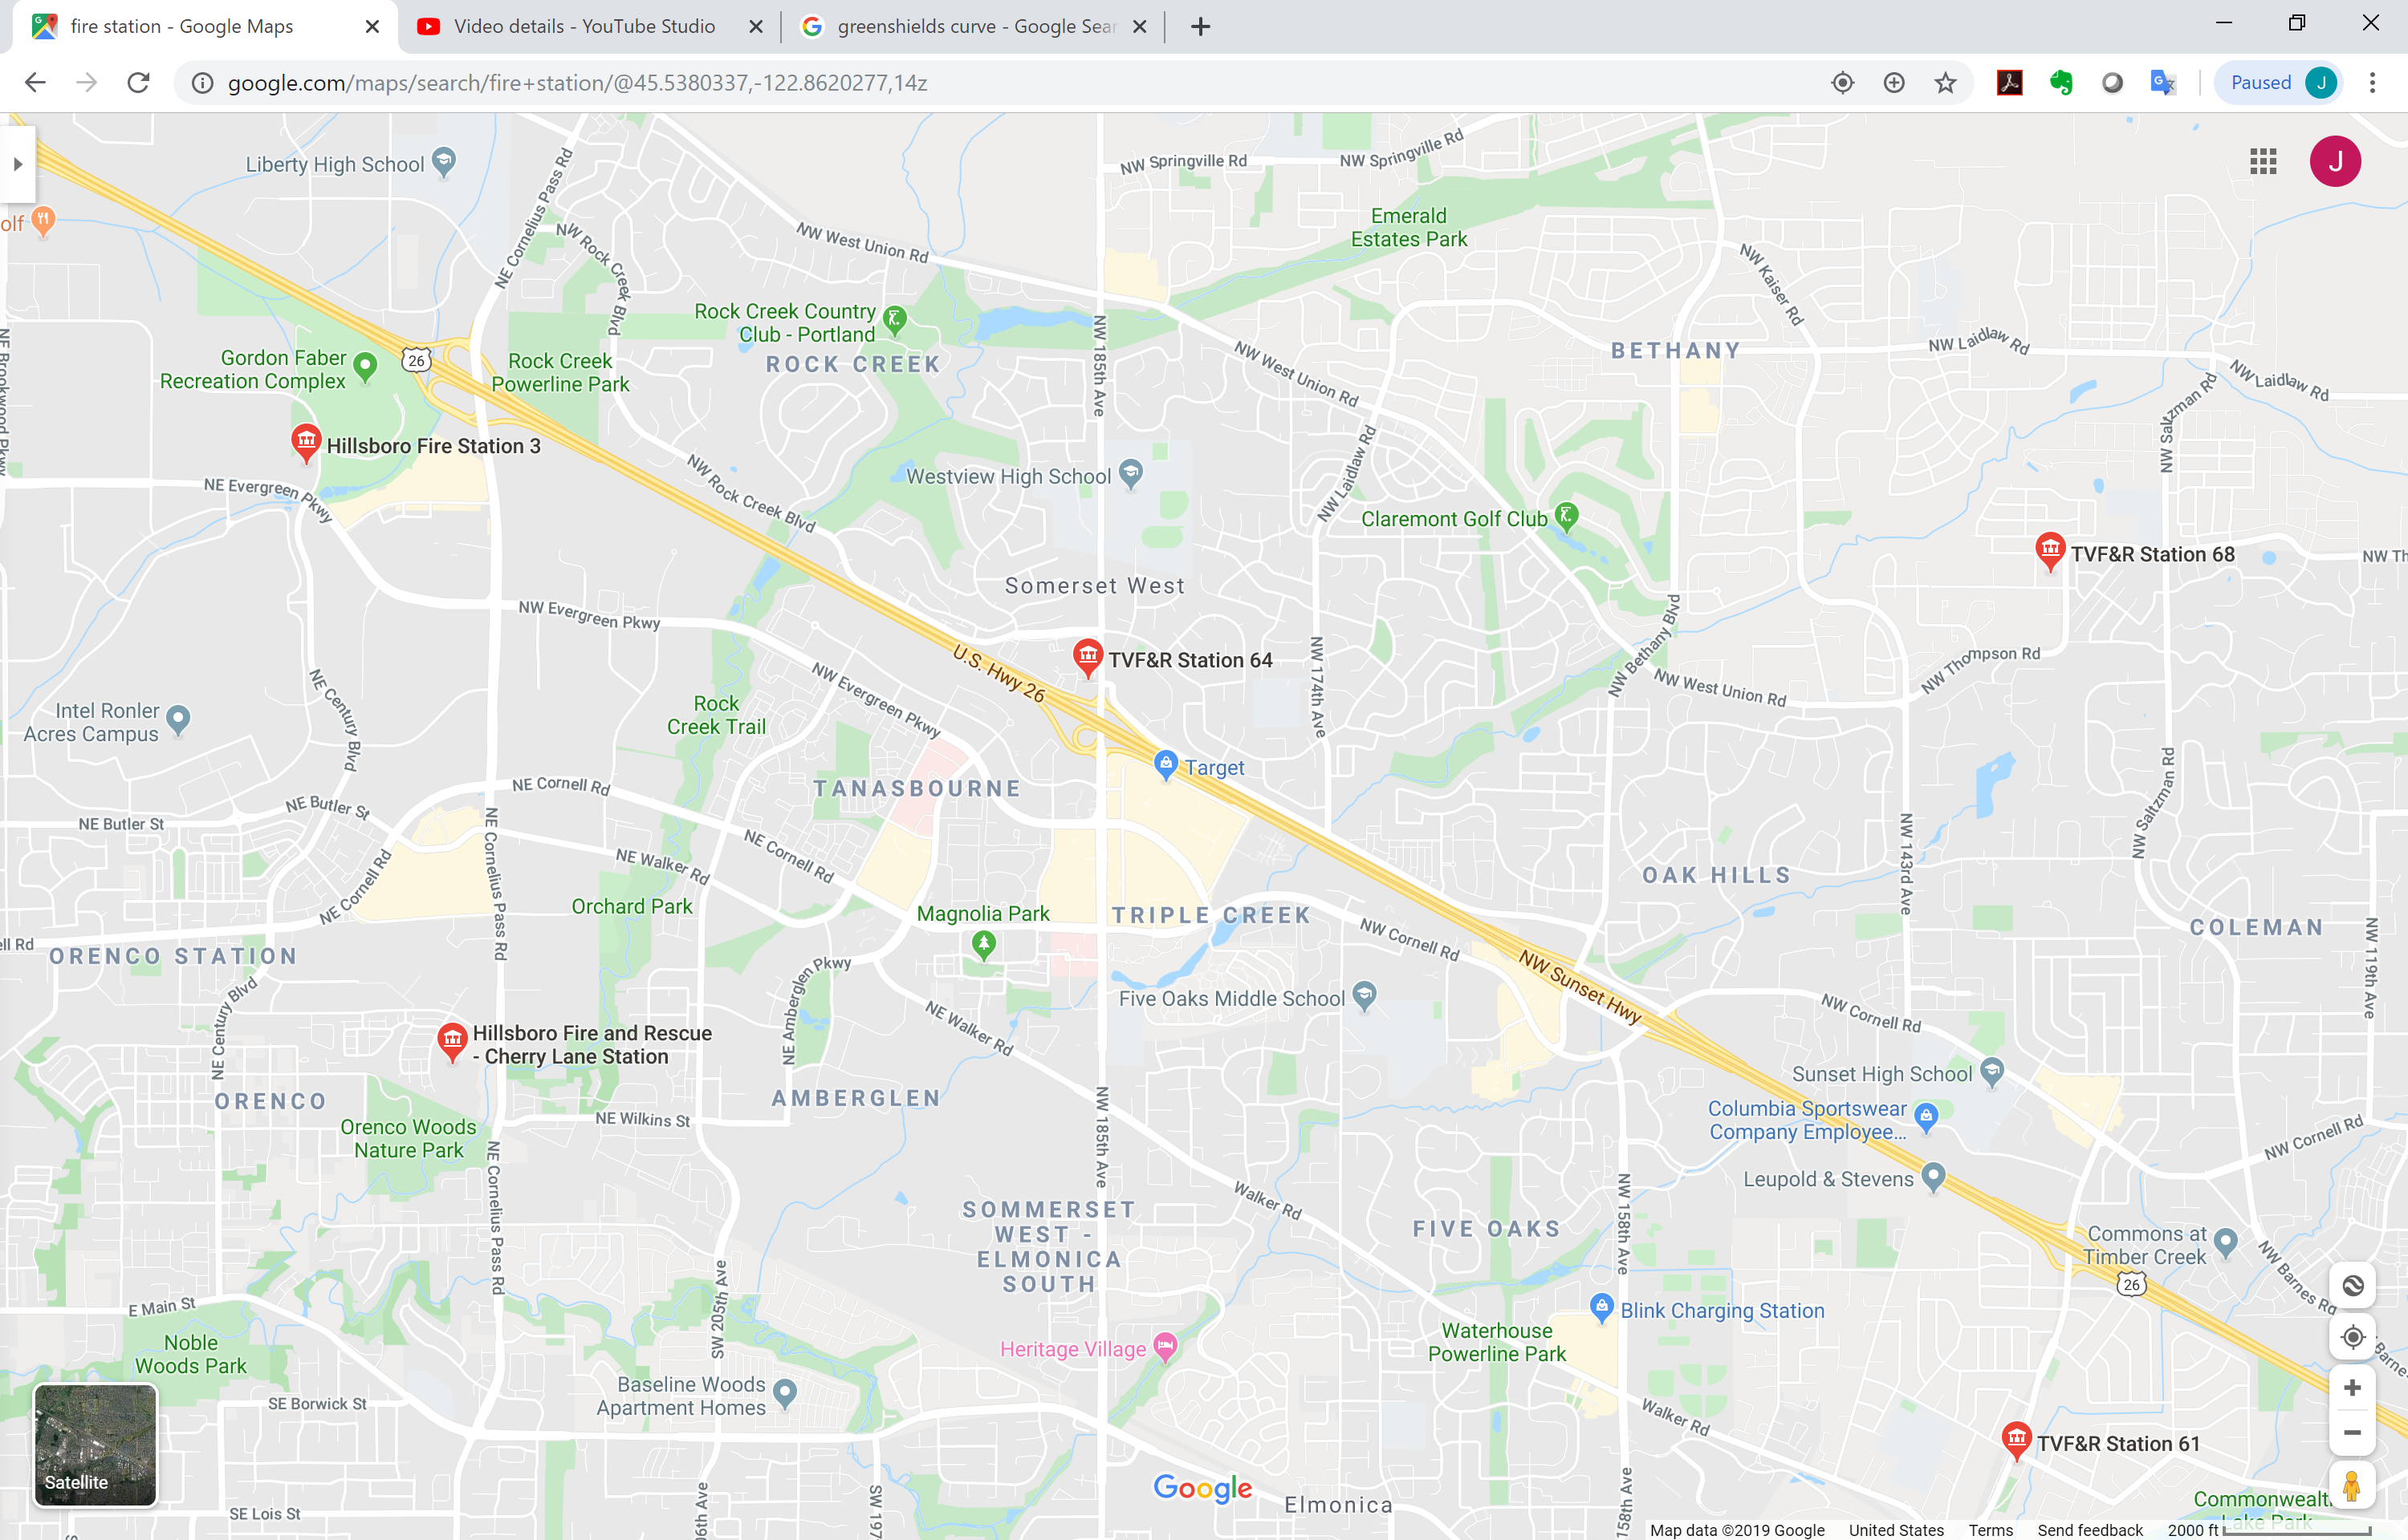

Figure Fire station locations in the region; one of them is right off WB Hwy 26th at 185th Ave.

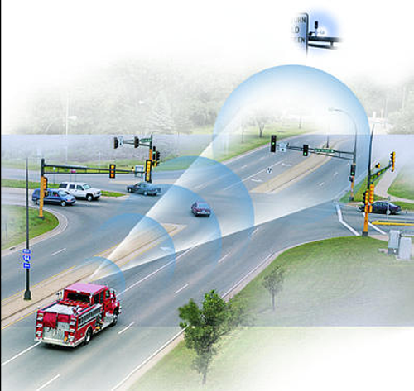In this region, the signalized intersections are equipped with a technology called signal preemption (<https://www.co.washington.or.us/LUT/TrafficSafety/DrivingSafety/traffic-signal-preemption.cfm>): whenever a fire engine or ambulance approaches, it sends a signal to the traffic lights and the lights will terminate other directions immediately or as soon as safety allows to give the emergency vehicles green light. While this technology can greatly increase the chance of saving lives or properties (for example, one NIH study showed that “Reducing ambulance response times to 5 minutes could almost double the survival rate for cardiac arrests not witnessed by ambulance crews.” <https://www.ncbi.nlm.nih.gov/pmc/articles/PMC32251/>). Yet fighting through a congested corridor is going to be a challenge no matter how traffic lights are responsive. Considering the non-linear effect of traffic congestion related to traffic volume increase as above, adding any unnecessary traffic could mean hampered chances in such emergency situations.

1. **Adding school traffic to a major interchange area seriously increase safety risks for the students and other traffic.**

As noted above, the Hwy 26/185th interchange area is featured by a mixed traffic from shoppers, commuters, delivery trucks, long-distance travelers. Adding school traffic to this mix will generate the one of the worst traffic compositions that can be imagined of (the missing nightmare piece is constant flow of heavy duty trucks that the shopping center can in fact also occasionally receive). The increase safety risks come from several aspects:

1. Usually the mix traffic has a vast difference of driving behavior and thus unexpected cooperation which typically result in higher accident rates;
2. Increased traffic congestion and stop-and-go traffic is a direct source to possible crashes due to distracted driving that is on the rise nationwide;
3. The slopes of the highway overpass brings extra difficulties for different vehicle types – fortunately we see less snow days in our region but we never fall short of rains and early dark evenings.
4. Any possible bike to school trips will inevitably expose to the risks at this interchange.

Disclaimer: *These qualitative analyses are all based on public information, and from civil engineer’s professional judgment. While it is not supported by traffic analysis studies that would require travel planning and traffic operation modeling and data analysis, the guiding principles of planning implications, traffic operational analysis and safety are usually how a travel planner and traffic engineer would approach the problem.*